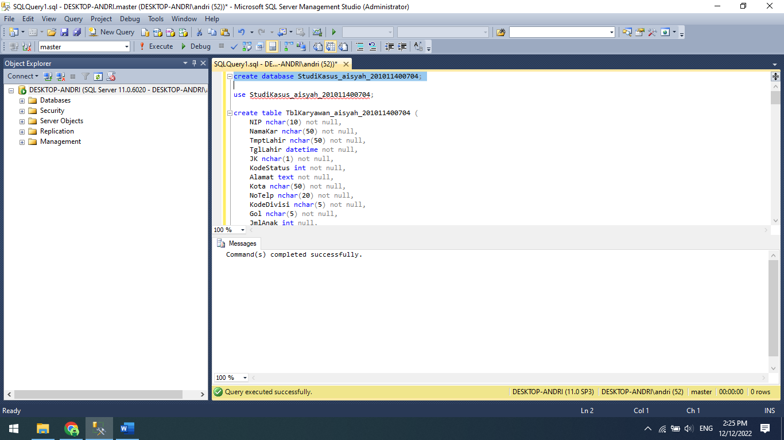

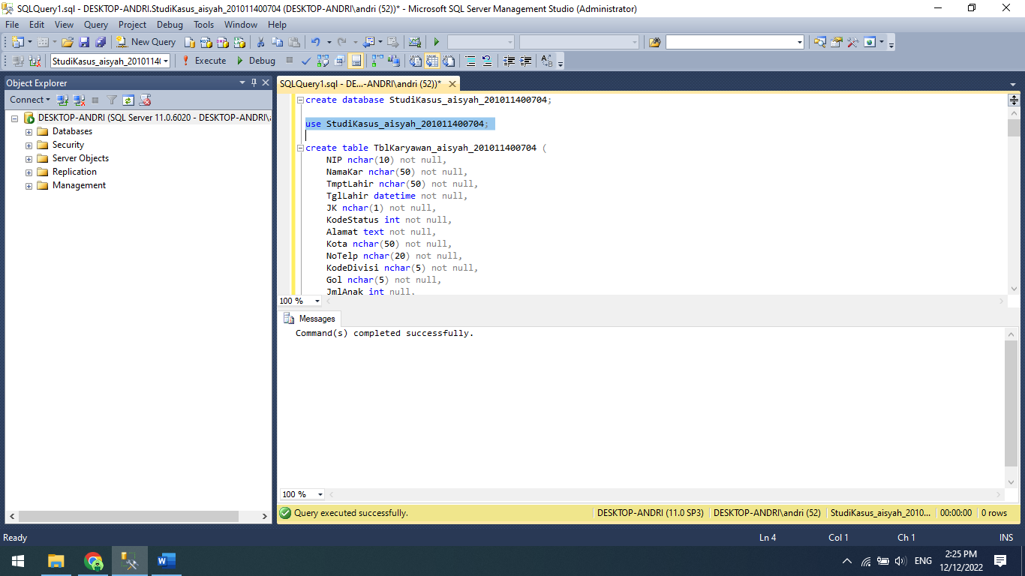

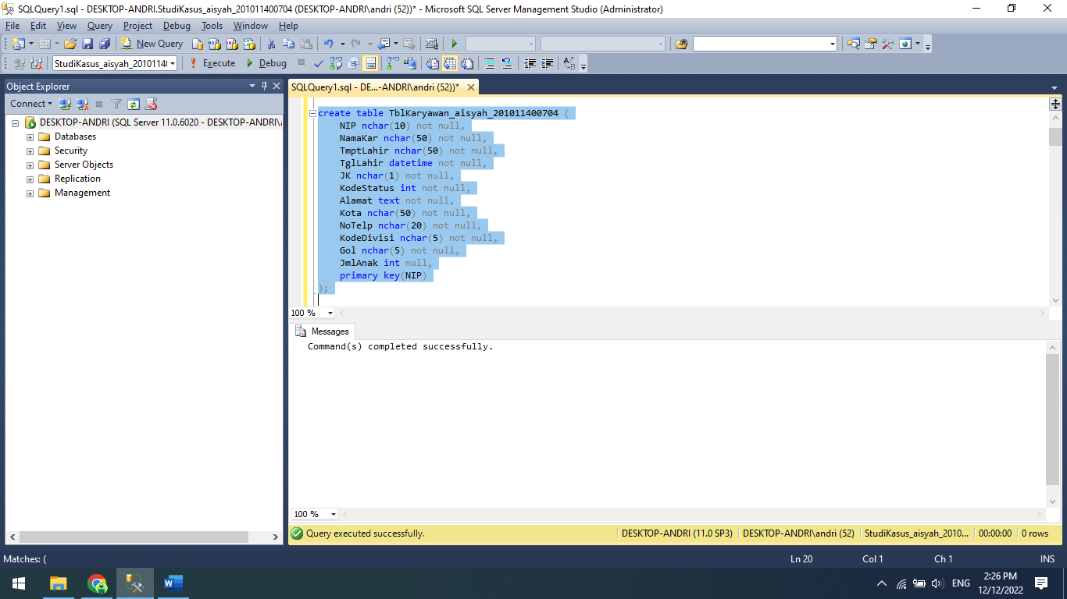

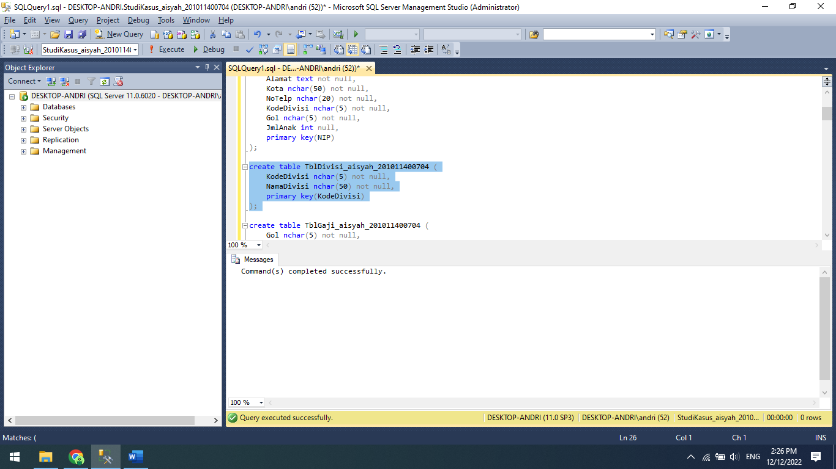

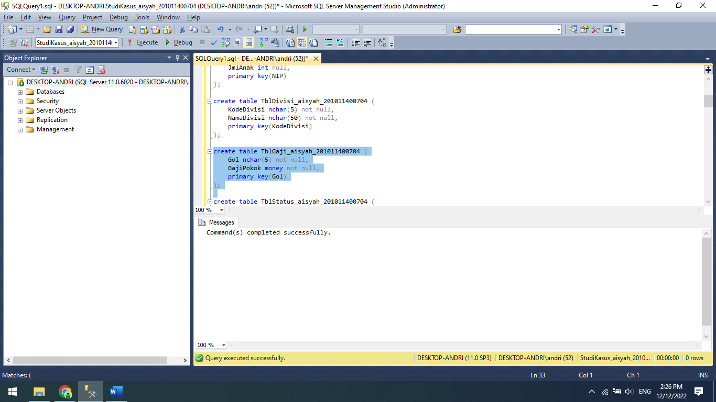

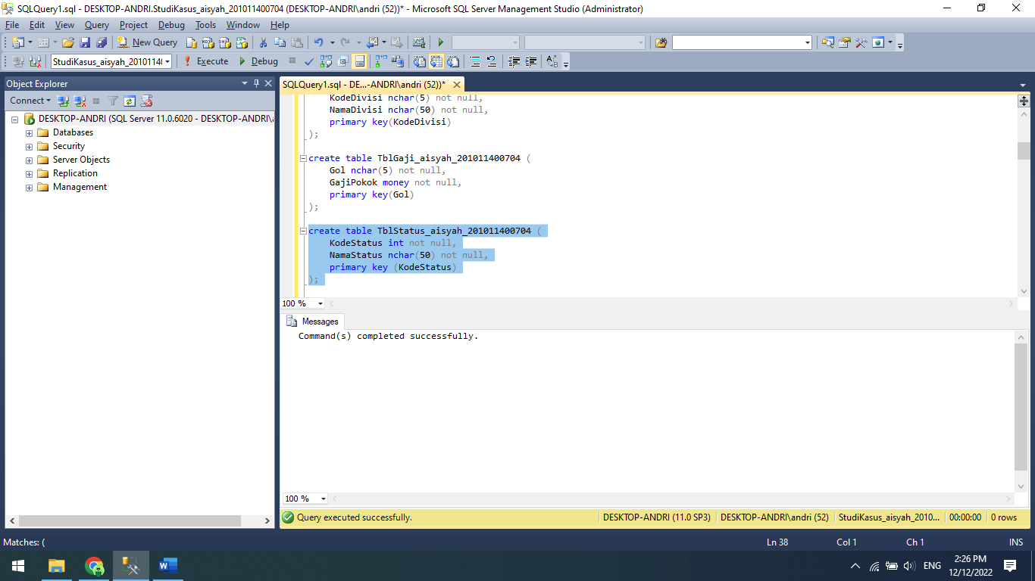

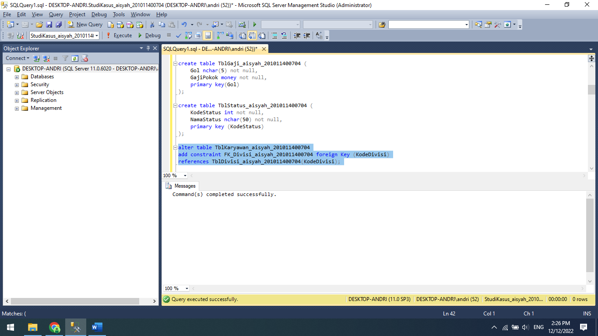

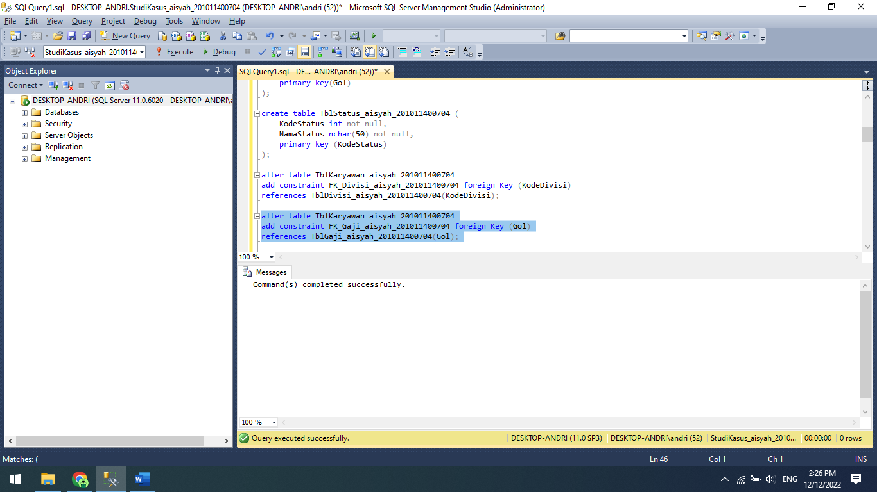

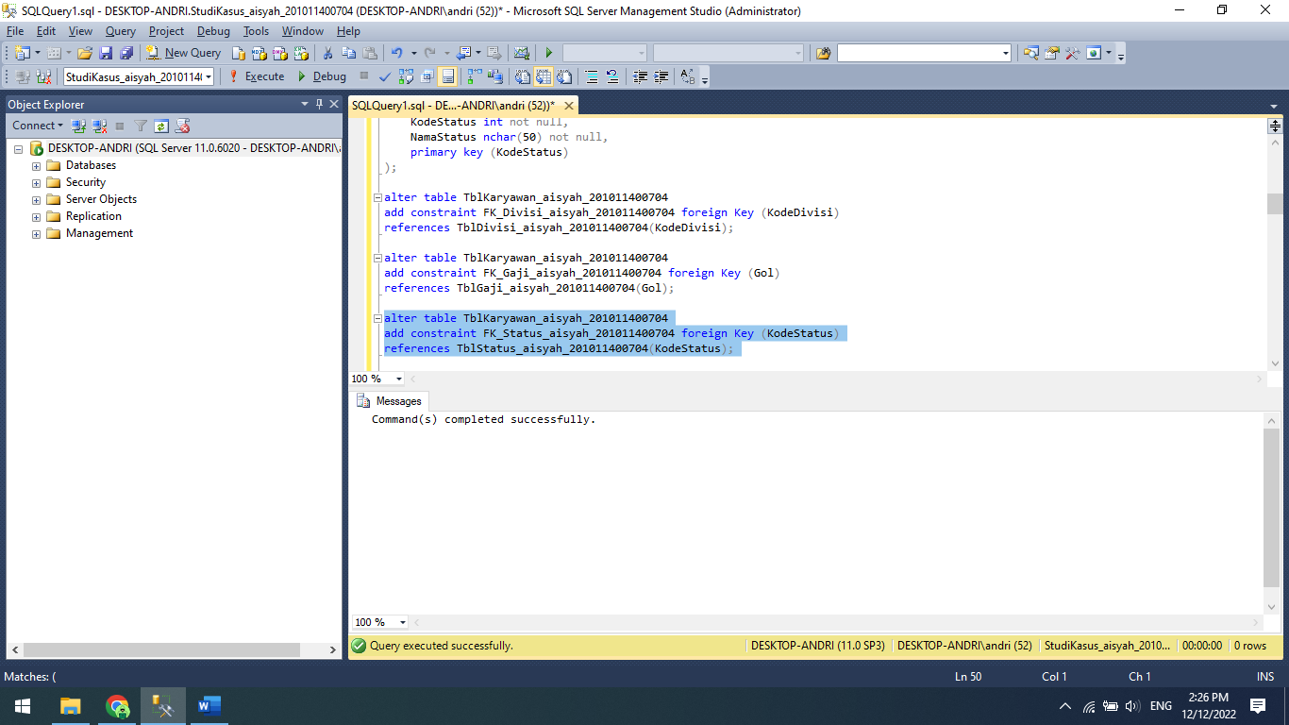

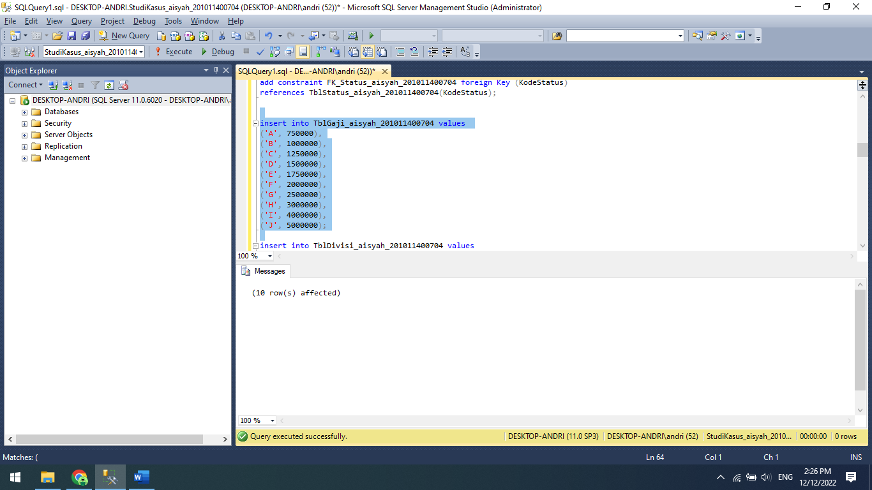

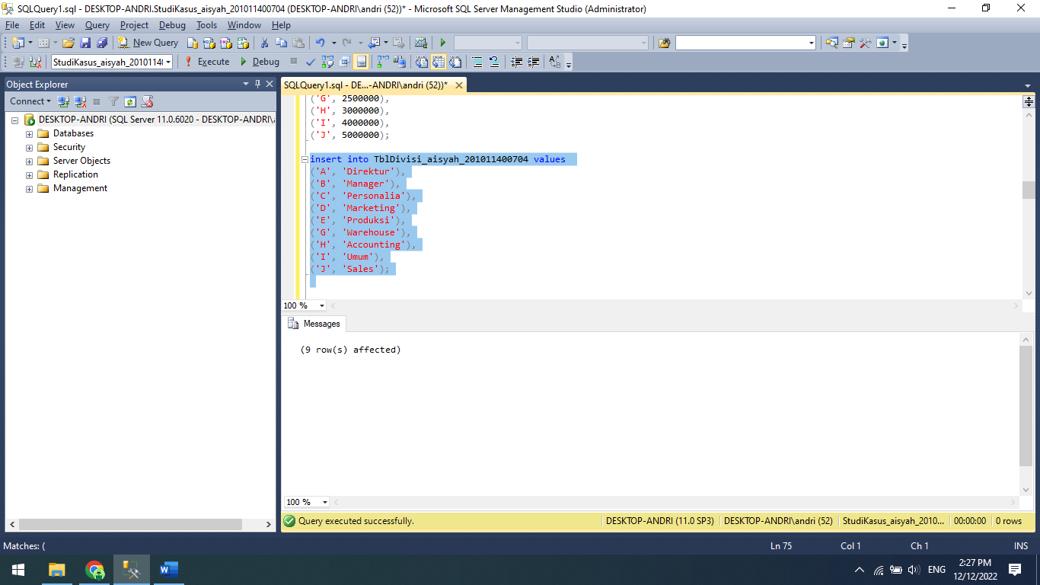

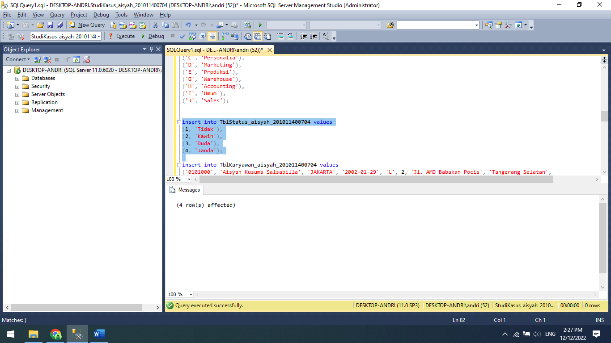

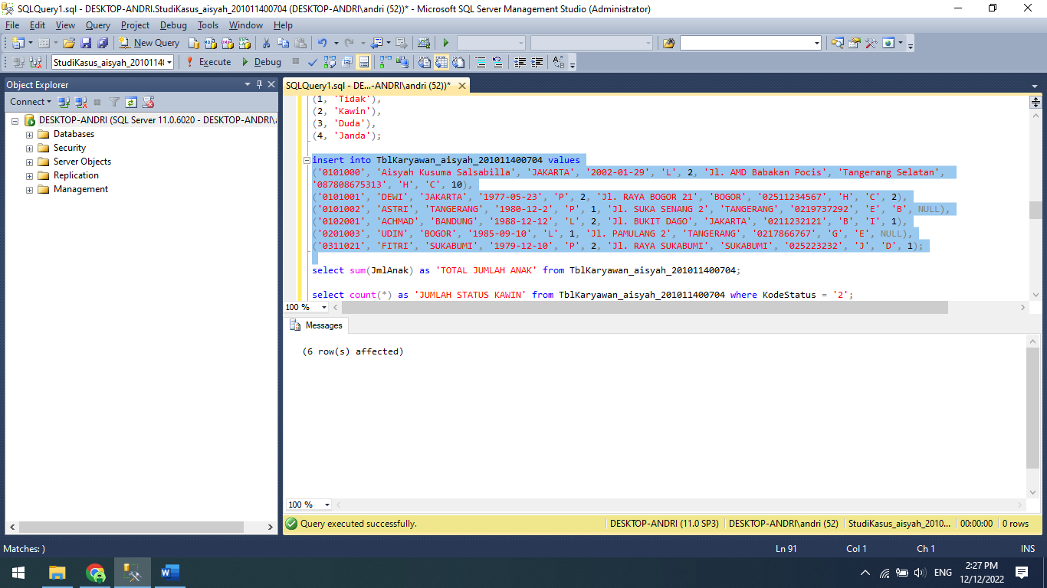

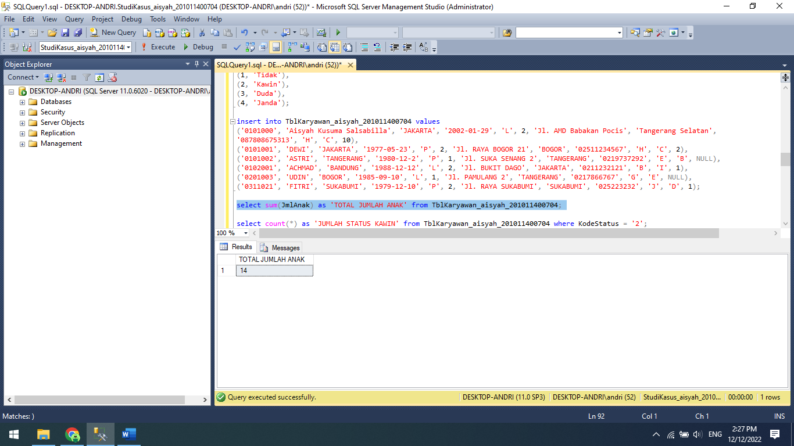

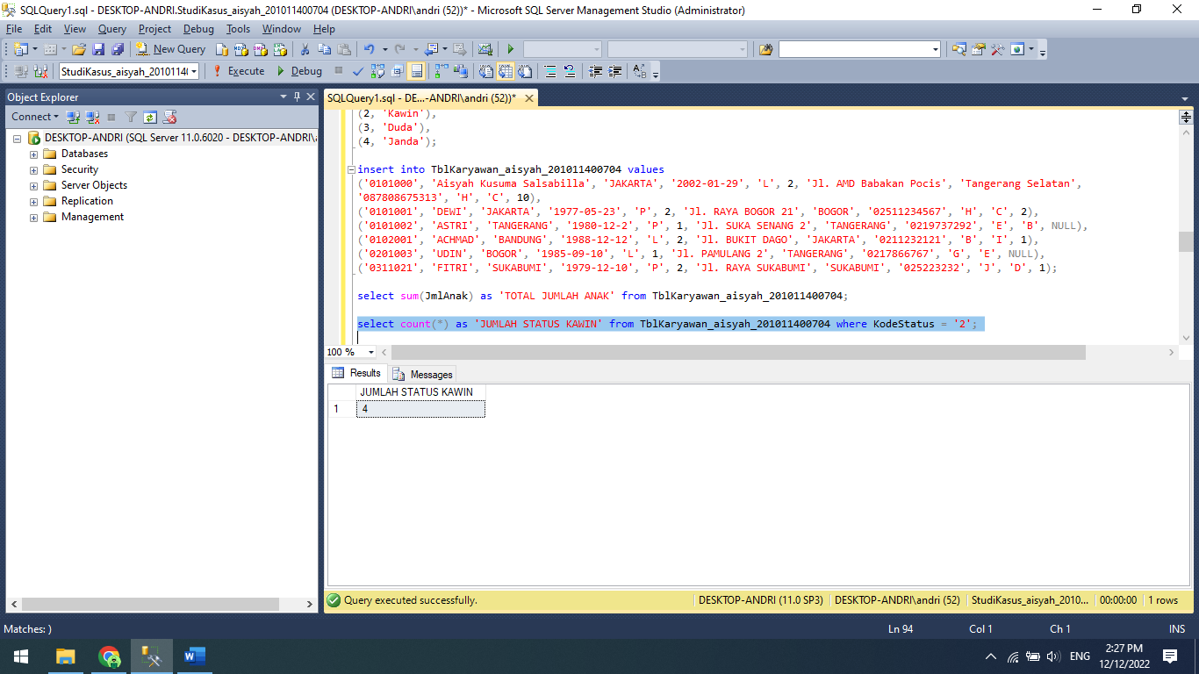

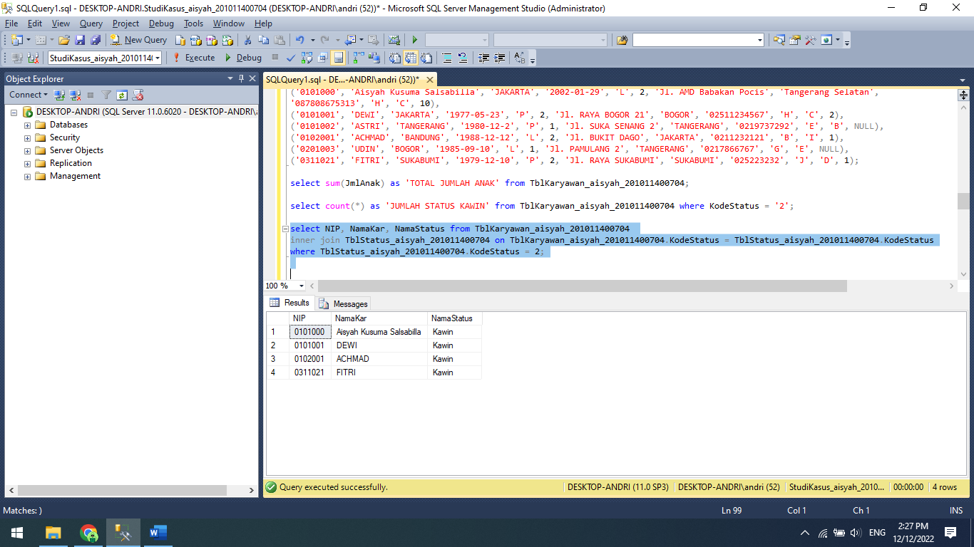

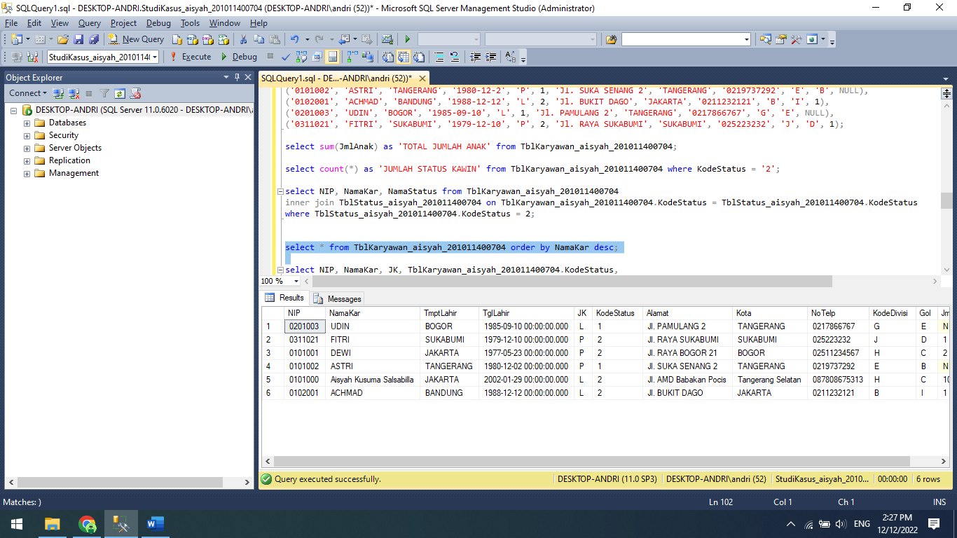

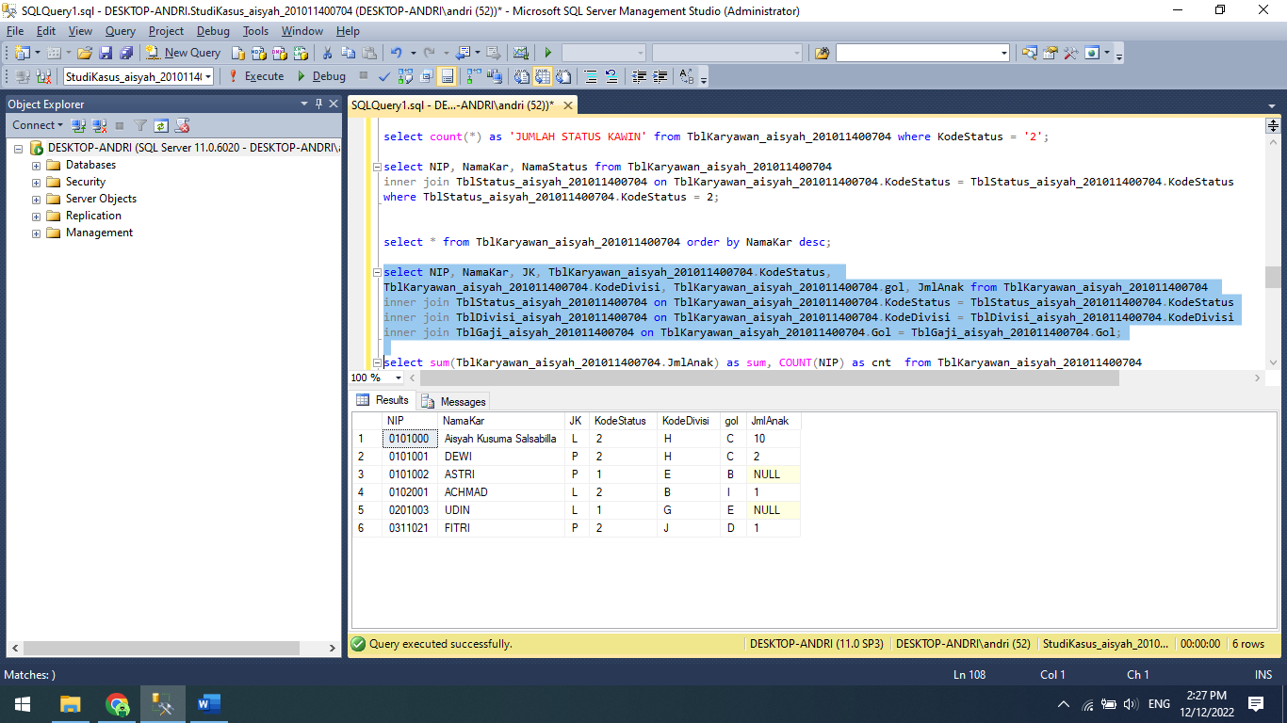

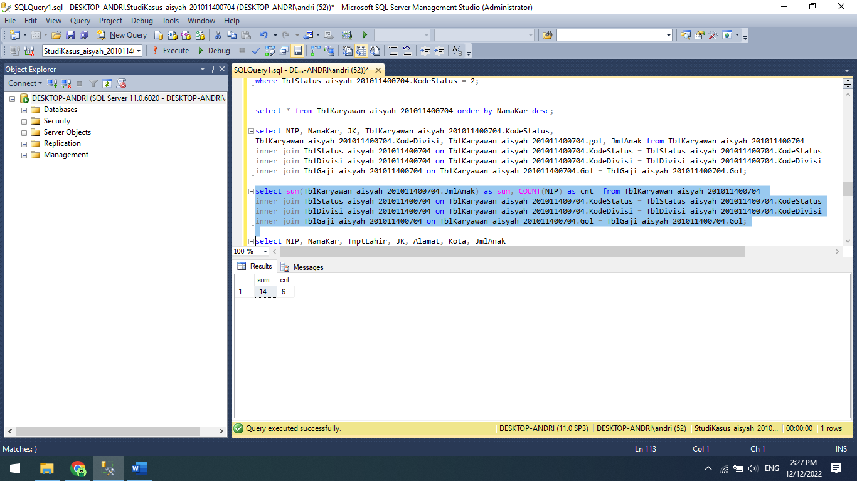

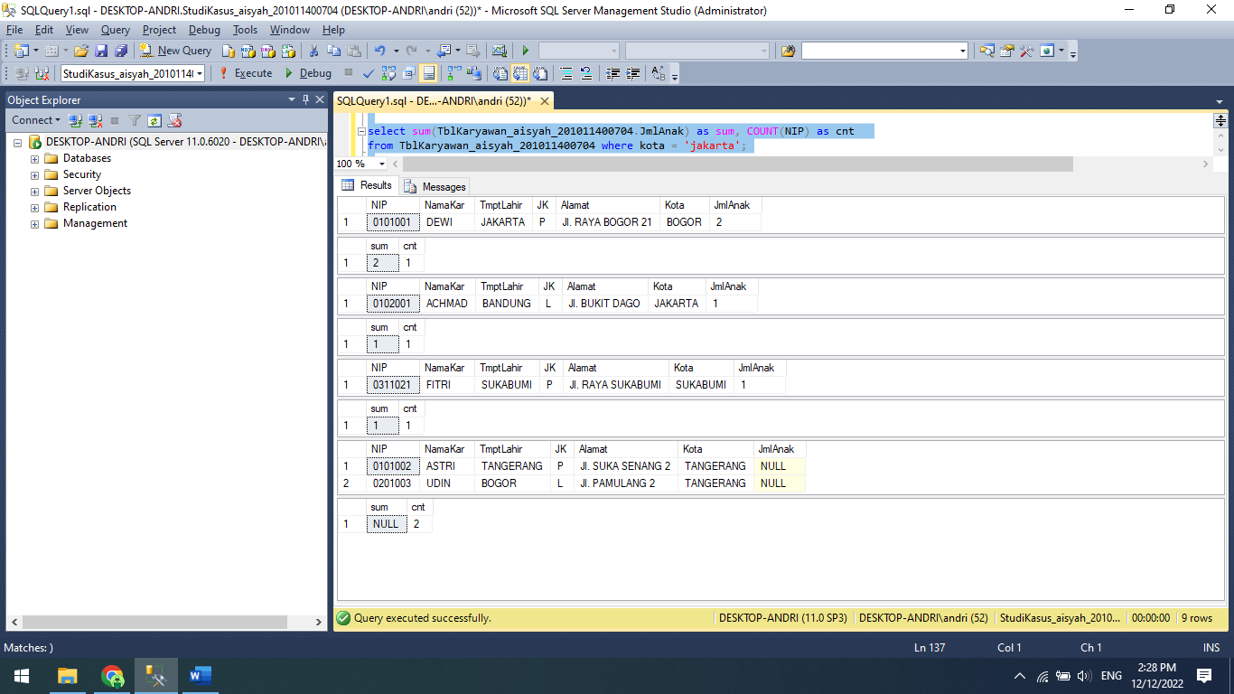

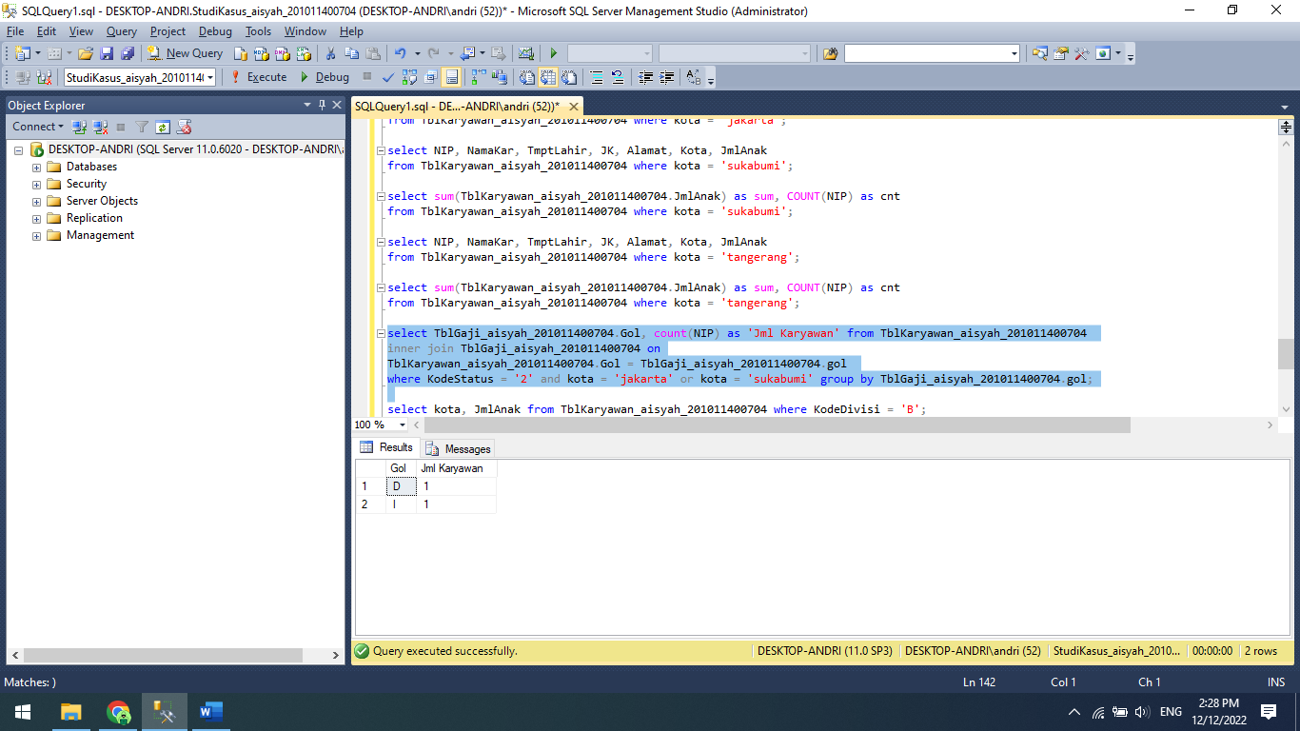

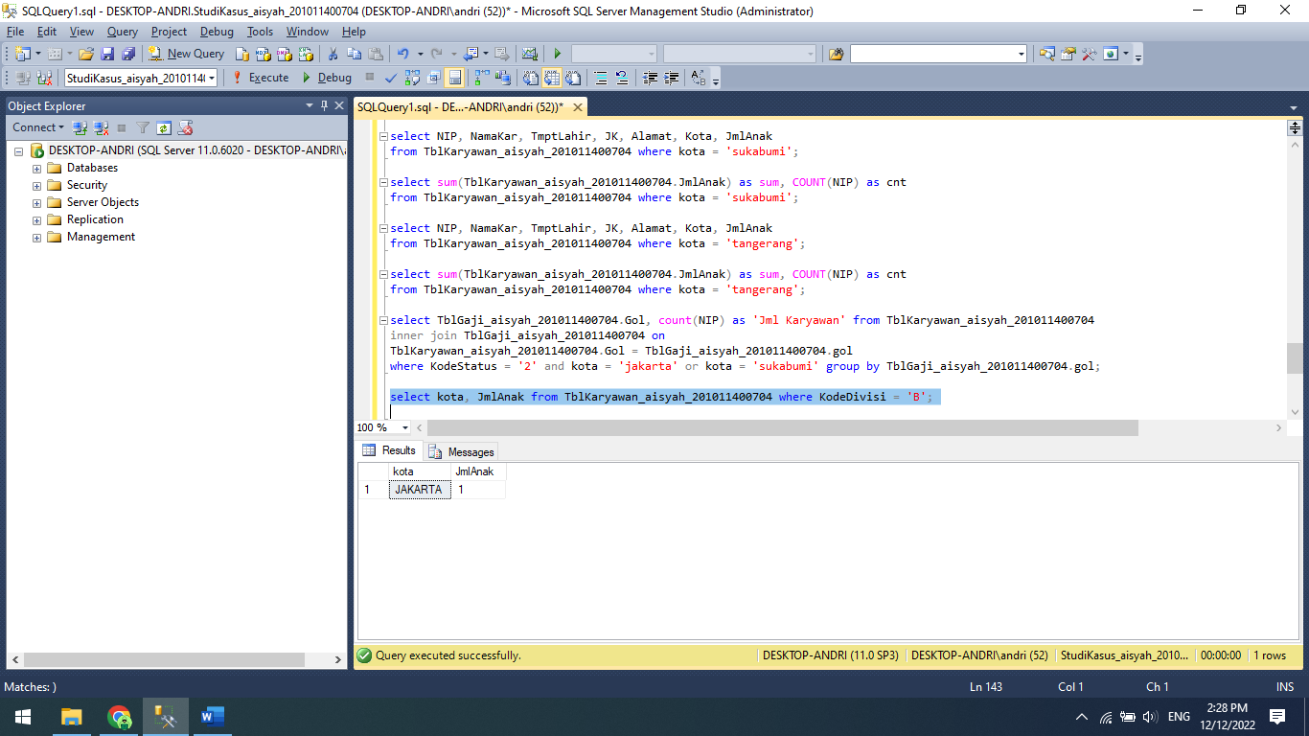

Source Code:

create database StudiKasus_aisyah_201011400704;

use StudiKasus_aisyah_201011400704;

create table TblKaryawan_aisyah_201011400704 (

NIP nchar(10) not null,

NamaKar nchar(50) not null,

TmptLahir nchar(50) not null,

TglLahir datetime not null,

JK nchar(1) not null,

KodeStatus int not null,

Alamat text not null,

Kota nchar(50) not null,

NoTelp nchar(20) not null,

KodeDivisi nchar(5) not null,

Gol nchar(5) not null,

JmlAnak int null,

primary key(NIP)

);

create table TblDivisi_aisyah_201011400704 (

KodeDivisi nchar(5) not null,

NamaDivisi nchar(50) not null,

primary key(KodeDivisi)

);

create table TblGaji_aisyah_201011400704 (

Gol nchar(5) not null,

GajiPokok money not null,

primary key(Gol)

);

create table TblStatus_aisyah_201011400704 (

KodeStatus int not null,

NamaStatus nchar(50) not null,

primary key (KodeStatus)

);

alter table TblKaryawan_aisyah_201011400704

add constraint FK_Divisi_aisyah_201011400704 foreign Key (KodeDivisi)

references TblDivisi_aisyah_201011400704(KodeDivisi);

alter table TblKaryawan_aisyah_201011400704

add constraint FK_Gaji_aisyah_201011400704 foreign Key (Gol)

references TblGaji_aisyah_201011400704(Gol);

alter table TblKaryawan_aisyah_201011400704

add constraint FK_Status_aisyah_201011400704 foreign Key (KodeStatus)

references TblStatus_aisyah_201011400704(KodeStatus);

insert into TblGaji_aisyah_201011400704 values

('A', 750000),

('B', 1000000),

('C', 1250000),

('D', 1500000),

('E', 1750000),

('F', 2000000),

('G', 2500000),

('H', 3000000),

('I', 4000000),

('J', 5000000);

insert into TblDivisi_aisyah_201011400704 values

('A', 'Direktur'),

('B', 'Manager'),

('C', 'Personalia'),

('D', 'Marketing'),

('E', 'Produksi'),

('G', 'Warehouse'),

('H', 'Accounting'),

('I', 'Umum'),

('J', 'Sales');

insert into TblStatus_aisyah_201011400704 values

(1, 'Tidak'),

(2, 'Kawin'),

(3, 'Duda'),

(4, 'Janda');

insert into TblKaryawan_aisyah_201011400704 values

('0101000', 'Aisyah Kusuma Salsabilla', 'JAKARTA', '2002-01-29', 'L', 2, 'Jl. AMD Babakan Pocis', 'Tangerang Selatan',

'087808675313', 'H', 'C', 10),

('0101001', 'DEWI', 'JAKARTA', '1977-05-23', 'P', 2, 'Jl. RAYA BOGOR 21', 'BOGOR', '02511234567', 'H', 'C', 2),

('0101002', 'ASTRI', 'TANGERANG', '1980-12-2', 'P', 1, 'Jl. SUKA SENANG 2', 'TANGERANG', '0219737292', 'E', 'B', NULL),

('0102001', 'ACHMAD', 'BANDUNG', '1988-12-12', 'L', 2, 'Jl. BUKIT DAGO', 'JAKARTA', '0211232121', 'B', 'I', 1),

('0201003', 'UDIN', 'BOGOR', '1985-09-10', 'L', 1, 'Jl. PAMULANG 2', 'TANGERANG', '0217866767', 'G', 'E', NULL),

('0311021', 'FITRI', 'SUKABUMI', '1979-12-10', 'P', 2, 'Jl. RAYA SUKABUMI', 'SUKABUMI', '025223232', 'J', 'D', 1);

select sum(JmlAnak) as 'TOTAL JUMLAH ANAK' from TblKaryawan_aisyah_201011400704;

select count(*) as 'JUMLAH STATUS KAWIN' from TblKaryawan_aisyah_201011400704 where KodeStatus = '2';

select NIP, NamaKar, NamaStatus from TblKaryawan_aisyah_201011400704

inner join TblStatus_aisyah_201011400704 on TblKaryawan_aisyah_201011400704.KodeStatus = TblStatus_aisyah_201011400704.KodeStatus

where TblStatus_aisyah_201011400704.KodeStatus = 2;

select * from TblKaryawan_aisyah_201011400704 order by NamaKar desc;

select NIP, NamaKar, JK, TblKaryawan_aisyah_201011400704.KodeStatus,

TblKaryawan_aisyah_201011400704.KodeDivisi, TblKaryawan_aisyah_201011400704.gol, JmlAnak from TblKaryawan_aisyah_201011400704

inner join TblStatus_aisyah_201011400704 on TblKaryawan_aisyah_201011400704.KodeStatus = TblStatus_aisyah_201011400704.KodeStatus

inner join TblDivisi_aisyah_201011400704 on TblKaryawan_aisyah_201011400704.KodeDivisi = TblDivisi_aisyah_201011400704.KodeDivisi

inner join TblGaji_aisyah_201011400704 on TblKaryawan_aisyah_201011400704.Gol = TblGaji_aisyah_201011400704.Gol;

select sum(TblKaryawan_aisyah_201011400704.JmlAnak) as sum, COUNT(NIP) as cnt from TblKaryawan_aisyah_201011400704

inner join TblStatus_aisyah_201011400704 on TblKaryawan_aisyah_201011400704.KodeStatus = TblStatus_aisyah_201011400704.KodeStatus

inner join TblDivisi_aisyah_201011400704 on TblKaryawan_aisyah_201011400704.KodeDivisi = TblDivisi_aisyah_201011400704.KodeDivisi

inner join TblGaji_aisyah_201011400704 on TblKaryawan_aisyah_201011400704.Gol = TblGaji_aisyah_201011400704.Gol;

select NIP, NamaKar, TmptLahir, JK, Alamat, Kota, JmlAnak

from TblKaryawan_aisyah_201011400704 where kota = 'bogor';

select sum(TblKaryawan_aisyah_201011400704.JmlAnak) as sum, COUNT(NIP) as cnt

from TblKaryawan_aisyah_201011400704 where kota = 'bogor';

select NIP, NamaKar, TmptLahir, JK, Alamat, Kota, JmlAnak

from TblKaryawan_aisyah_201011400704 where kota = 'jakarta';

select sum(TblKaryawan_aisyah_201011400704.JmlAnak) as sum, COUNT(NIP) as cnt

from TblKaryawan_aisyah_201011400704 where kota = 'jakarta';

select NIP, NamaKar, TmptLahir, JK, Alamat, Kota, JmlAnak

from TblKaryawan_aisyah_201011400704 where kota = 'sukabumi';

select sum(TblKaryawan_aisyah_201011400704.JmlAnak) as sum, COUNT(NIP) as cnt

from TblKaryawan_aisyah_201011400704 where kota = 'sukabumi';

select NIP, NamaKar, TmptLahir, JK, Alamat, Kota, JmlAnak

from TblKaryawan_aisyah_201011400704 where kota = 'tangerang';

select sum(TblKaryawan_aisyah_201011400704.JmlAnak) as sum, COUNT(NIP) as cnt

from TblKaryawan_aisyah_201011400704 where kota = 'tangerang';

select TblGaji_aisyah_201011400704.Gol, count(NIP) as 'Jml Karyawan' from TblKaryawan_aisyah_201011400704

inner join TblGaji_aisyah_201011400704 on

TblKaryawan_aisyah_201011400704.Gol = TblGaji_aisyah_201011400704.gol

where KodeStatus = '2' and kota = 'jakarta' or kota = 'sukabumi' group by TblGaji_aisyah_201011400704.gol;

select kota, JmlAnak from TblKaryawan_aisyah_201011400704 where KodeDivisi = 'B';